**INTRODUCTION**

**Background of the Study**

The world’s interconnection has become complex due to the improvements in technology and the Internet. With the advent in the development of these improvements, computer and network security has become a major concern. For instance, a certain person access a malicious site without knowing that there is an attacker behind that site that can destroy or retrieve important data in a computer or a server. Because of this occurrence, a lot of important transactions can be affected. Worst, most of these destructive programs have the capabilities of not being detected by an antivirus or an intrusion detection system. In addition, these strategies is not common to all people and several software can detect it. Every year, there are reports of security issues – not only in individual devices, but also through the network. Though there are different security and protection tools available online, still threats are becoming more sophisticated as time passes.

A number of tools are available online developed by the open source community – where most of these open-source programs are helpful in protecting the network itself, regardless of the number of clients connected to the network. With proper configuration and execution, these programs will be helpful for network administrators in managing the network.

Because of these observations, the need for a program that will prevent network attacks and protect a system. The proponents planned creating a new type of system that will serve as a multi-tool for network administrators that will not only view and manage a network, but can also generate results and can detect rules that was set for the network.

**Objectives of the Study**

The general objective of the study is to develop a Network Utility System that will cater the needs of the network administrator in network security.

Specifically the study aims:

1. To design and develop utility system with the following features:
2. ***Network Scanner*** which is the main features of this system. It is compose of python scripts that was intended to scan the network to determine the active ports.
3. ***Result Generator*** is the one responsible in collecting the scan results and saving it to a database.
4. ***Network-Attack Adviser*** helps the administrator to mitigate or prevent a common network attack.
5. ***Intrusion Detection System*** that detects the rules that was set to the network and the data allowed by the system’s firewall.
6. ***Event Viewer*** display processes in the terminal.
7. To design and develop a utility system that will help network administrator in preventing common network attacks
8. To design and develop a utility system that will generate a report which will serve as documentation for the network administrator while the system is running.

**Scope and Limitations of the Study**

This study covers the scanning the network, generating logs for monitoring, advising common network attack and managing a network activities. Delimitation on the other hand includes the following:

* The system is not able to scan large range of network due to the large amount of data that will be saved in database
* The system can generate reports in readable format for common attacks and registered malwares only.
* System database cannot handle big amount of data gathered from network scanning within a limited period of time.

**Beneficiaries of the Study**

As per NetSec Manager operations, the possible beneficiaries of the system are the network and security administrator since the main features of this system is about scanning the network, generating scan results for monitoring, advising mitigation for common network attacks, intrusion detection system that will detect data allowed by the firewall and the event viewer which will display the processes in the terminal. Other beneficiaries may be the IT specialist who is also aware of this features.

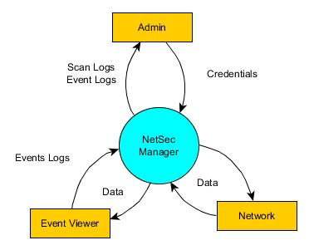

Figure 1: Conceptual Diagram

The Administrator will input his credentials (username and password) to operate the system. Once the system validated the credentials the administrator will be given two option: To scan the network or to check the event viewer. If the administrator choose to scan the network, NetSec Manager will start scanning the network while fetching the data, once the result is provided, the result will be saved to the database for documentation purposes. Other choice will be the event viewer. The event viewer will display the daily activities in the system/terminal for monitoring purposes.

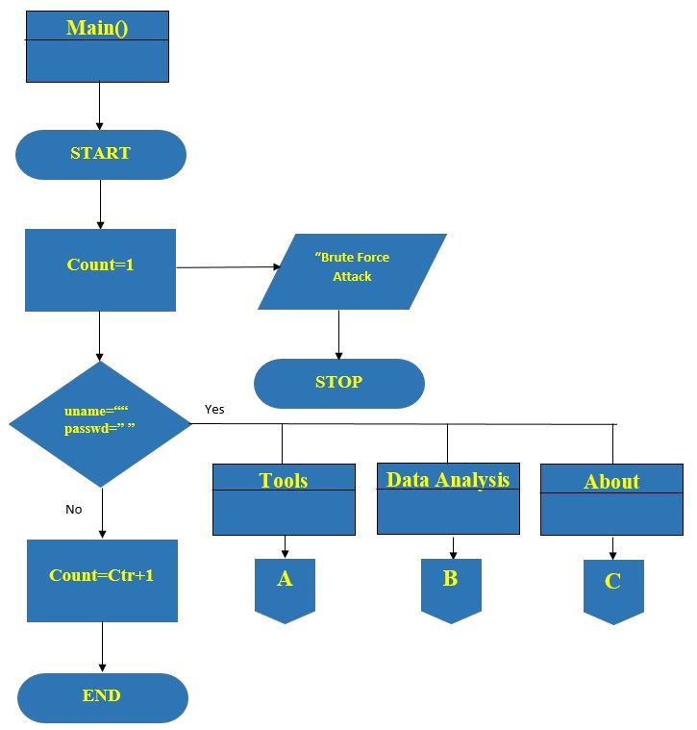

Figure 2: Main Program of NetSec Manager

In figure 2. The main program of NetSec Manager is explained via program flowchart. Starting from the login menu, the administrator is given 3 times to enter his credentials. If the credentials is correct, NetSec Manager will redirect to the main menu consist of the 3 different modules: Tools, Data Analysis and About. If the credentials did not match the credentials in the database, the system will automatically end the administrator’s session.

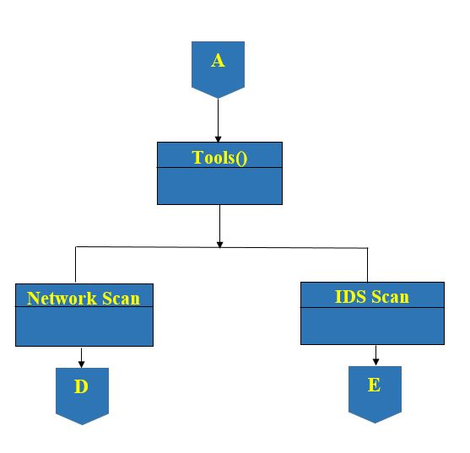

Figure 2.1: Tools module of the NetSec Manager

In figure 2.1, The Tool modules is expanded. Under the Tool module, the Network Scan and IDS Scan module is located. This module is the one responsible in scanning the network for scanning the network and detecting the rules set in the network and the data allowed by the firewall. This modules is also connected to the system database for the generating of results.

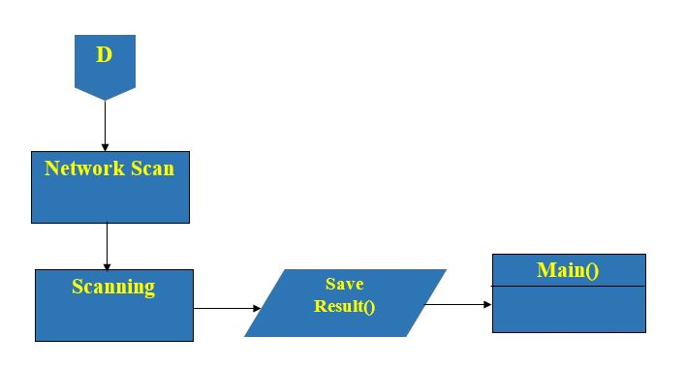

Figure 2.2: Network Scan module of the NetSec Manager

In figure 2.2, The Network Scan module is expanded. This module is the main feature of NetSec Manager. Once the scanning is initiated, the results of the scanning is automatically saved in the NetSec Manager database.

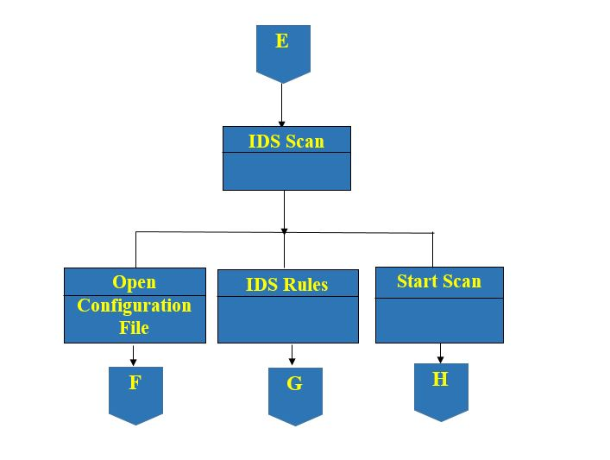

Figure 2.3: IDS Scan module of the NetSec Manager

In this figure, the IDS Scan module is expanded. IDS Scan module is composes of 3 sub modules, the Open Configuration File module, the IDS Rule module and the Start Scan module

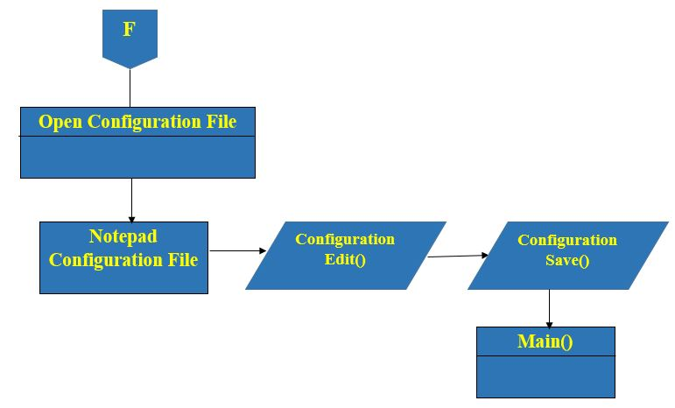

Figure 2.4: IDS Scan module of the NetSec Manager

In this figure, the Open Configuration File module is expanded. In this module, the administrator can update or edit the IDS Configuration file to insert any changes he want to implement for the network.

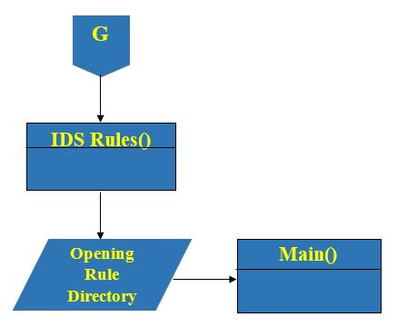

Figure 2.5: IDS Rules module of the NetSec Manager

In this figure, the directory of the IDS Rule is located. The administrator can view the storage of the IDS rules that was use in the IDS and the rules implemented in the network.

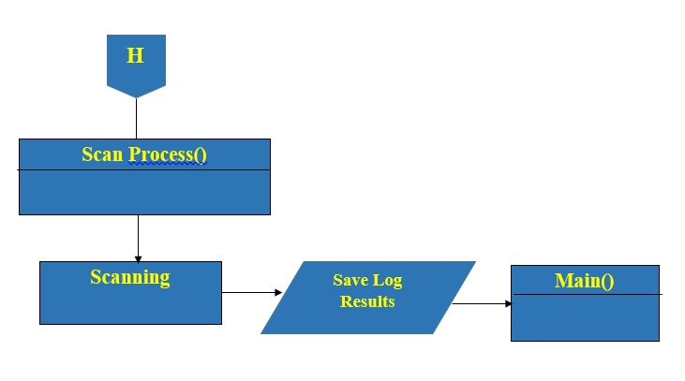

Figure 2.6: Scan Process module of the NetSec Manager

In this figure, the process of scanning the network is shown, once the administrator stop scanning the network, the results will be saved to the NetSec database and the result can be generated from the database for monitoring purposes.

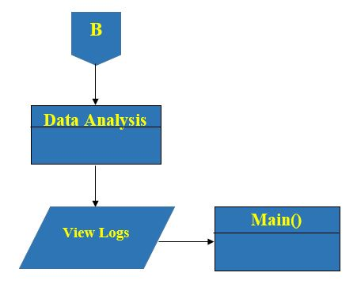

Figure 2.7: Data Analysis module of the NetSec Manager

This figure shows the expanded Data Analysis module. Under this module, the View Log is located. View logs module contains the saved scan results fetched from the database together with logs from the event viewer.

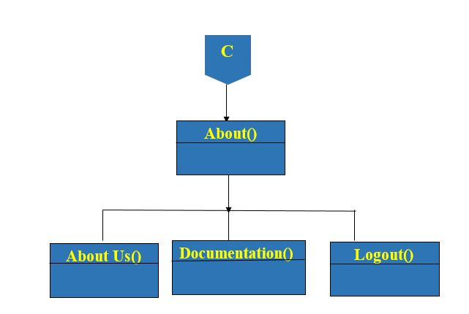

Figure 2.8 About module of the NetSec Manager

In this figures, the About module is expanded. The About Us Module is composes of About Us module, Documentation module and Logout Module.

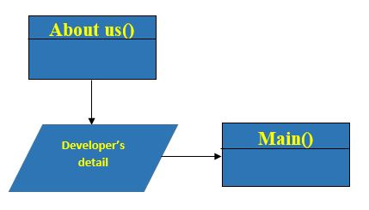

Figure 2.9 About Us module of the NetSec Manager

In figure 2.6, The About Us module is expanded. This module contains the details regarding the developer or the proponents of the study. Once the administrator is done with the About Us module, he can always go back to the main menu.

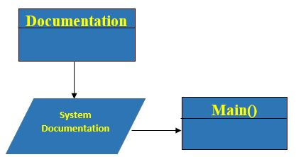

Figure 2.10 Documentation module of the NetSec Manager

In figure 2.7, The Documentation module is expanded. This module contains the copy of the documents regarding the system. Once the administrator is done with the About Us module, he can go back to the main menu.

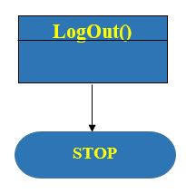

Figure 2.11 Logout module of the NetSec Manager

In figure 2.11, The Logout module is located inside the About module. This module will be terminate the session was the administrator click it.

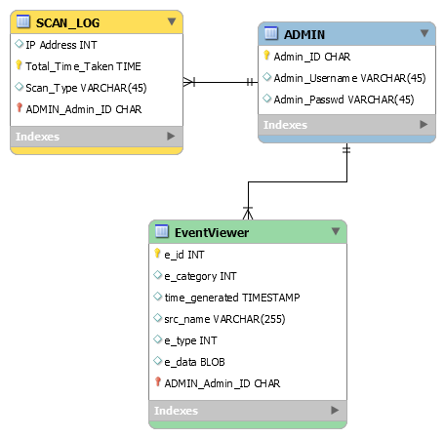

Figure 3: Entity-Relationship Diagram

NetSec Manager will use Mongo database system to generate results from scan. NetSec Manager Entity relationship diagram will be compose of the Administrator table that is connected to the Scan Log table and Event Viewer. Under the Administrator Table is the following attributes: Administrator ID, Administrator Username and Administrator Password which will serve as the administrators credential in using the system. While under Scan Log table is IP Address, Total Time Taken, Scan Type and the foreign key Administrator ID which will be collected from the results of the scan that is fetched from the database. On the other hand under the Event Viewer table is Event ID, Event Category, Time Generated, Source Name, Event Type, Event Data and foreign key of Administrator ID which will be gathered from the process happened in the terminal while the administrator is away.

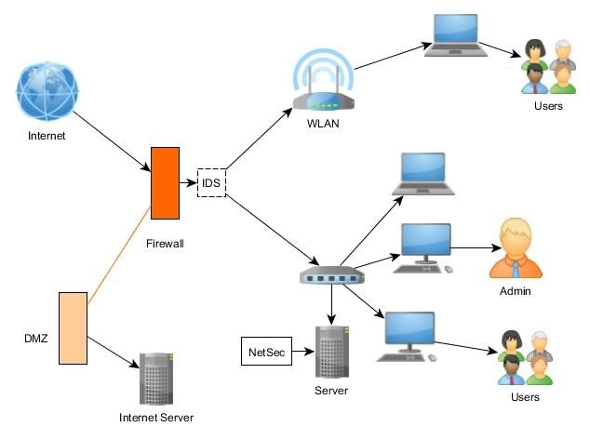Figure 4: Network Diagram

Figure 4 shows the network diagram of NetSec. It shows where the system will be deployed in the network. As seen in the figure, the intrusion detection system is placed behind the firewall. WLAN and the router (wired network) is connected to the IDS. In the wired network, computers that were used by the administrators and IT specialists are connected, as well as the server where NetSec is located.

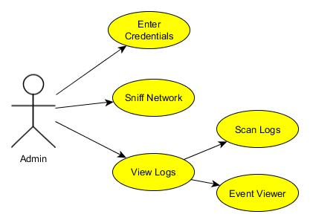Figure 5: Unified Modeling Language

Unified Modeling Language helps the users how to visualize the design of a system. In this figure, the proponents shows the relationship of the administrator to the NetSec Manager features. The Administrator is the actor while the features is the use case. NetSec can be visualize with this UML since our system focuses on the use of the network and security administrator.

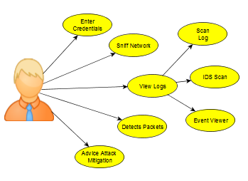

Figure 6: Use Case Diagram

The figure shows the use case diagram of NetSec. This shows the capability of the administrator in using the system. Once the network administrator has entered his/her credentials, through NetSec, he/she has the capability to sniff the network, view logs from the scan log, event viewer and the logs generated in the IDS scan, detects packets behavior through the IDS, and view the advice attack mitigation.

**Table 1.0 Use Case Specifications for Enter Credentials**

|  |  |  |
| --- | --- | --- |
| USE CASE NAME | Enter Credentials | |
| ACTOR(S) | Admin | |
| DESCRIPTION | The administrator needs to login with his credentials for him to use the system. | |
| BASIC FLOW | Action Actor | System Response |
| **Step 1.** The Administrator will enter his username and password.  **Step 2.** Administrator needs to click the login button. | **Step 3.** The system will check on its database if the username and password entered is correct.  **Step 4.** Once the system has already done with verifying the credentials, it will grant the access to the administrator.  **Step 5.** The main menu will now appear. |

**Table 2.0 Use Case Specifications for IDS Scan.**

|  |  |  |
| --- | --- | --- |
| USE CASE NAME | IDS Scan | |
| ACTOR(S) | Admin | |
| DESCRIPTION | The administrator will conduct IDS scan. An Intrusion Detection System that checks for the connections being allowed by the firewall. | |
| BASIC FLOW | Action Actor | System Response |
| **Step 1.** A menu screen will pop out with 3 tabs: Tools, Data Analysis and About. The Administrator will have to choose the Tool tab.  **Step 2.**Under the Tool tab, the Administrator has three choices. If he/she hovered the IDS menu, sub-menus will appear: Open Configuration File, Rules and Start Scan (CMD). If he/she click the Open Configuration File.  **Step 4.** The Administrator has another choice of Rules. If he/she click the Rules.  **Step 6.** The administrator may edit delete and create IDS rules. He/she can also check rules implemented before.  **Step 7.**The Administrator has the remaining choice of the Start Scan (CMD). If he/she click the Start Scan (CMD).  **Step 9.** If the administrator has already done with going to the Start Scan (CMD), he/she can go back to the main menu. | **Step 3.** The system will direct to the configuration file.  **Step 5.**  The system will redirected to the rules folder of snort.  **Step 8.** The system will redirect to the command prompt. |

|  |  |  |
| --- | --- | --- |
| USE CASE NAME | Network Scan | |
| ACTOR(S) | Admin | |
| DESCRIPTION | The administrator will conduct a network-layer scan to determine all the active terminals and its activities. | |
| BASIC FLOW | Action Actor | System Response |
| **Step 1.** A menu screen will pop out with 3 tabs: Tools, Data Analysis and About. The Administrator will have to choose the Tool tab.  **Step 2.**Under the Tool tab, the Administrator has two choices. If he/she hovered the Network Scan menu, sub-menu will appear: Sniffer and Event Viewer.  **Step 5.** If the administrator has already done with going to the sniffer, he/she can go back to the main menu. | **Step 3.** The system will pop out interface of the Sniffer.  **Step 4.**  The Sniffer will automatically run. The results of the scan will be displayed, at the same time, these details will be saved in a database. |

**Table 3.0 Use Case Specifications for Network Scan.**

|  |  |  |
| --- | --- | --- |
| USE CASE NAME | Data Analysis | |
| ACTOR(S) | Admin | |
| DESCRIPTION | The administrator will conduct a network-layer scan to determine all the active terminals and its activities. | |
| BASIC FLOW | Action Actor | System Response |
|  | **Step 1.** A menu screen will pop out with 3 tabs: Tools, Data Analysis and About. The Administrator will have to choose the Data Analysis tab.  **Step 2.**Under the Data Analysis tab, the Administrator will be seeing a submenu – View Data.  **Step 5.** If the administrator has already done with going to the View Data, he/she can go back to the main menu. | **Step 3.** The system will pop out interface of the View Data.  **Step 4.**  The interface has a button with a label “Load Data”. When clicked, the interface will be able to display all the details recorded during the scan. |

**Table 4.0 Use Case Specifications for Data Analysis.**

**Table 5.0 Use Case Specifications for Attack Adviser.**

|  |  |  |
| --- | --- | --- |
| USE CASE NAME | Attack Adviser | |
| ACTOR(S) | Admin | |
| DESCRIPTION | The administrator will be viewing the most common attacks that happens in the network. | |
| BASIC FLOW | Action Actor | System Response |
|  | **Step 1.** A menu screen will pop out with 3 tabs: Tools, Data Analysis and About. The Administrator will have to choose the Tool tab.  **Step 2.**Under the tool tab, the Administrator will be seeing 3 submenus – Network Scan, IDS Scan, and Attack Adviser. The administrator will have to choose the Attack Adviser.  **Step 4.** If the administrator has already done with going to the Attack Adviser, he/she can go back to the main menu. | **Step 3.** The system will pop out the attack adviser document. |

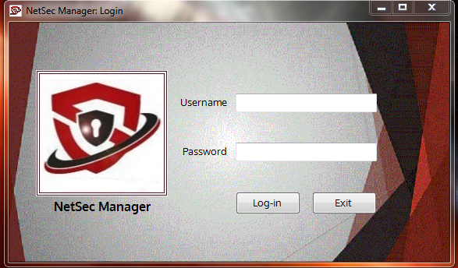

Figure 7: Screen Layout for Login Interface

This is the login screen layout of the NetSec Manager. In the username and password input box, the network administrator will have to input the given credentials to be able to log-in and use the system. The administrator will be given two options, The Log-in and Exit Button. Clicking the log-in button will give the network administrator access to the whole feature of the system. And clicking on exit button will terminate the log-in screen.

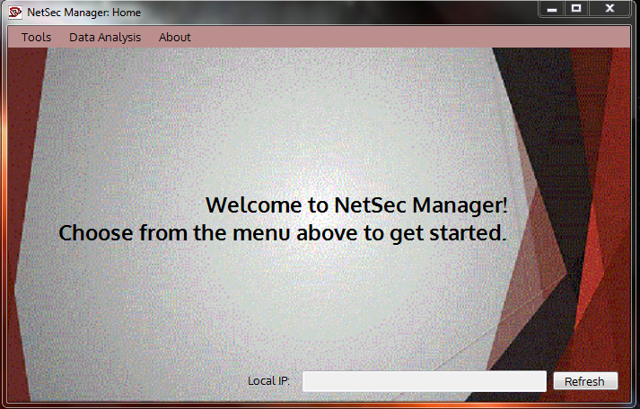

Figure 7.1: Screen Layout for Main Menu

After the administrator has enter his credentials and authenticated in the database, the main menu screen layout will appear. On the upper left part is the 3 main modules of the system. Under the tools module are Network Sniffer, Attack Adviser and IDS Scan sub-menus, which has different process. In the data analysis module, the network administrator can be able to view the data logs captured under the tools module. And under the about module, the network administrator can either view the documentation of the researchers on the system or log-out in the system.

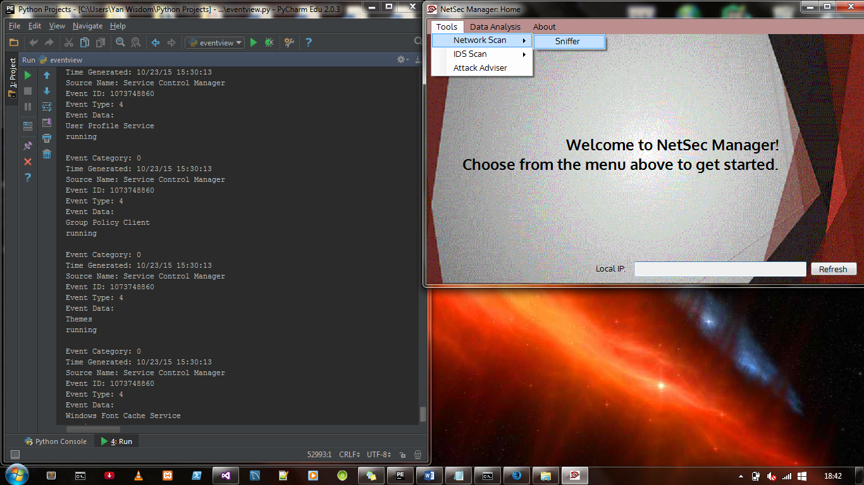

Figure 7.2: Screen Layout for Network Sniffer

After the network administrator clicked on the Sniffer shown above, the scanning of network begins. The process can only be stop manually by the admin. While scanning, the process of scanning the network can be view as like the given figure above.

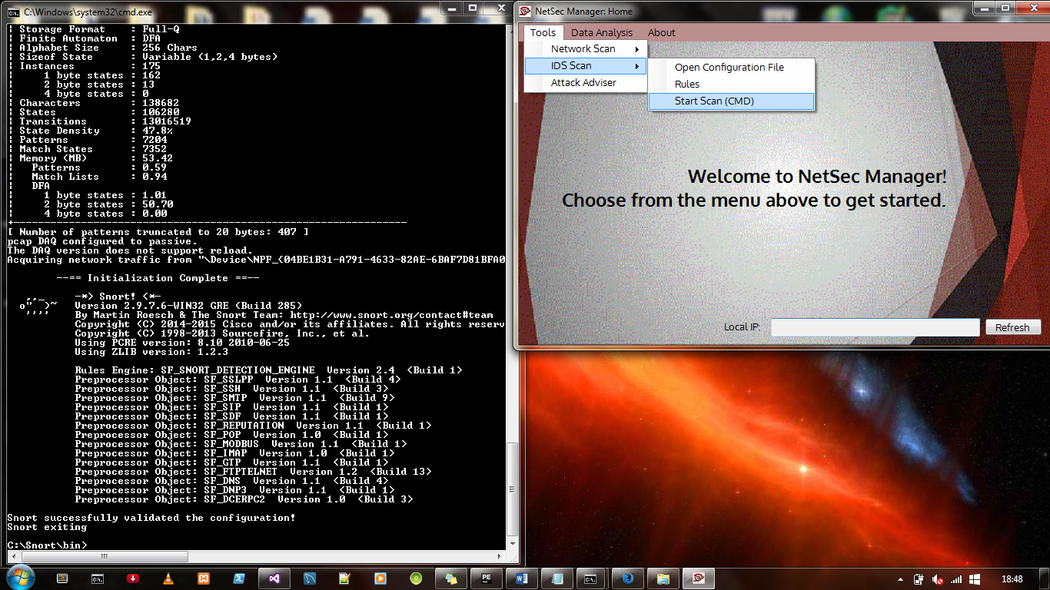

Figure 7.3: Screen Layout for IDS Scan

After clicking on Start Scan inside the IDS Scan, the command line screen will pop out and automatically starts scanning. The process of scanning the network can be view as like the given figure above.

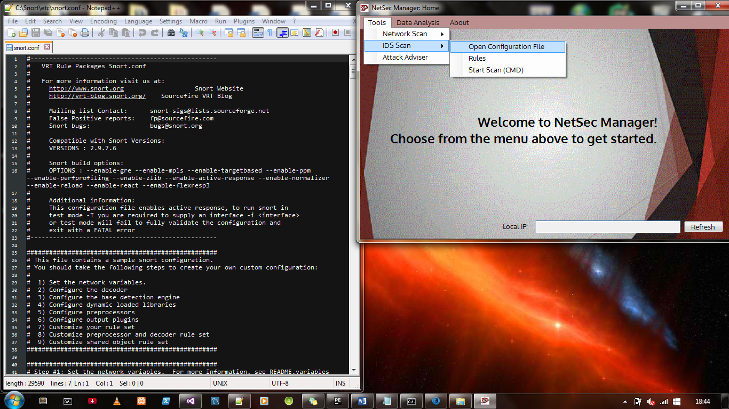

Figure 7.4: Screen Layout for Open Configuration File

Clicking on the Open Configuration File opens the IDS configuration file in a text editor, where the network administrator will be able to set the rules he or she wants to enable, the speed of the scan, and the behavior of the IDS itself – on how to run in the network. During the scan the logs being generated is then saved to a database.

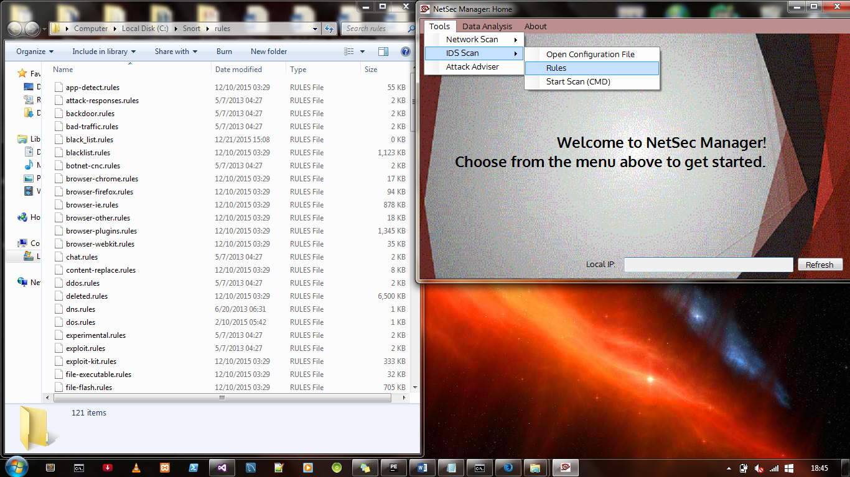Figure 7.5: Screen Layout for Rule Directory

When the administrator clicks the Rules module, it will automatically open the folder where all the rule files are saved. Then the administrator has the capability to edit these rules and implement it to the system.

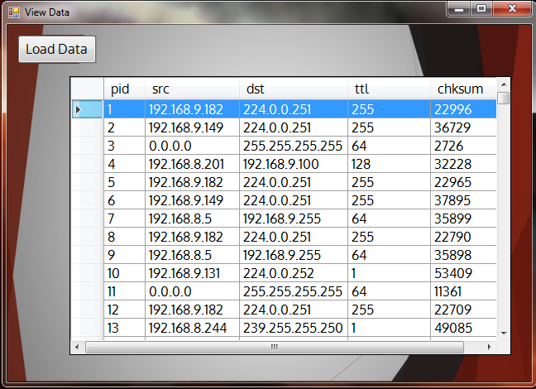

Figure 7.5: Screen Layout for View Data

When the administrator clicks the Load Data button, data saved in the database will then be viewed in this interface. He or she will be able to view the logs generated during the sniff and the IDS. Inside the generated data is the listed pid which is the generated Packet ID, While the src is the source ip and dst is the destination, Time to live (ttl) is for the packet to reach its destination, Lastly the chksum protects the header of IPv4 data packets against data corruption.

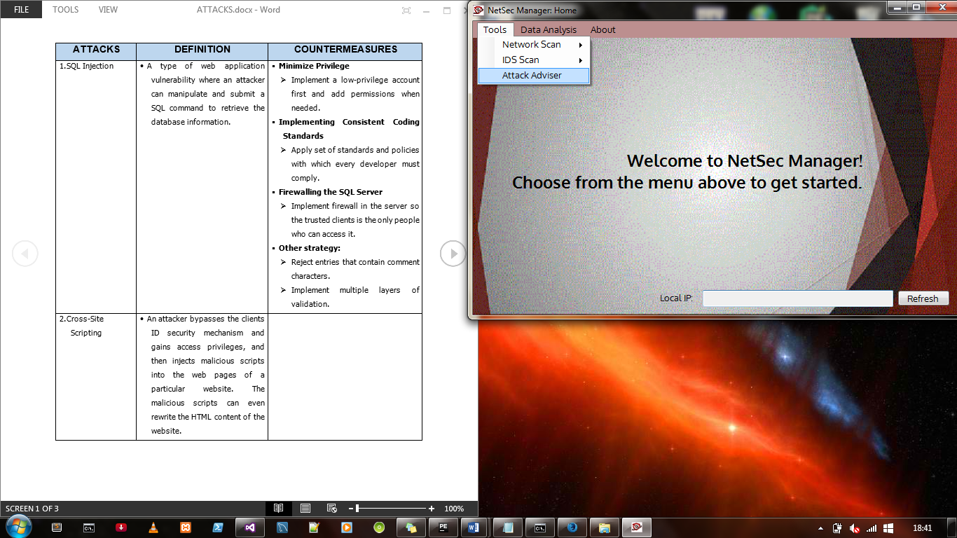Figure 7.6: Screen Layout for Attack Adviser

The network administrator can seek help on how to mitigate common network attacks by clicking the Attack Adviser module. This contains the name of the attack, the definition, and the countermeasures in order to mitigate, if not prevent, the said attack.

**MANUAL**

**DEFINITION OF TERMS**

**OPERATIONAL TERMS**

**BUFFER OVERFLOW.** Occurs when a program or process tries to store more data in a buffer that it was intended to hold.

**CONTEXT AND DATA FLOW DIAGRAMS** Displays the interaction between the system and the users/entities; shows the movement of data within the system to and/or from the entities.

**CROSS-SITE SCRIPTING** An attack technique that involves echoing attacker-supplied code into a user’s browser instance.

**DENIAL-OF-SERVICE (DOS)** An attempt to make a machine or network resource unavailable to its intended users.

**DNSPYTHON** A DNS toolkit for Python. It supports almost all record types.

**Intrusion Detection System** Known as intrusion detection system, IDS is a device or software application that monitors network or system activities for malicious activities or policy violations and produces reports to a management station.

**IPV4 ADDRESS** Known as the Internet Protocol version 4, it is a unique identifier to assigned to a network device, either automatically or set by the user.

**MAC ADDRESS.** Known as media access control address, MAC address is a unique identifier assigned to network interfaces for communications in the physical network segment.

**MYSQL CONNECTOR PYTHON** A standardized database driver for Python platforms and development.

**NETADDR** A Python library for representing and manipulating network addresses.

**NETIFACES** Provides a way for Python programmers to get access to a list of the network interfaces on the local machine, and to obtain the addresses of those network interfaces.

**PORT** Virtual data connection between computer programs possibly through a computer network.

**PYTHON** A general-purpose, object-oriented interpreted language used for countless standalone projects or scripting applications.

**SESSION HIJACKING**  is a method of taking over a web user session by surreptitiously obtaining the session ID and masquerading as the authorized user.

**SNORT.** An open-source and lightweight network intrusion detection system for UNIX derivatives and Windows

**SQL INJECTION.** A code injection technique, used to attack data-driven applications, in which malicious SQL statements are inserted into an entry field for execution.

**TCP/IP** Internet protocols, namely, TCP (Transmission Internet Protocol), the first networking protocols defined in the Internet protocol suite.

**VISUAL BASIC** A programming environment from Microsoft in which a programmer uses a graphical user interface (GUI).

**WEBSNORT** Provides a web interface for user and system submission of packet capture files to run against IDS instances.

**XAMMP** A free open source cross-platform web server solution stack package.

**TECHNICAL TERMS**

**CREDENTIAL** Proof of identity of a person that is required before using the services of the system.

**SNIFF** Packet sniffing allows individuals to capture data as it is transmitted over a network.

**OPERATION**

1. In order to operate the utility, NetSec Manager. The network administrator needs to login, he/she needs to input the given username and password.
2. After logging-in, it will be redirected to the main page. It is where the tools, the logs and the other actions are placed. Under the tools are Sniff Network, Edit Configuration file, Rule Directory and Start Scan.
3. If the network administrator chooses the Sniff Network. This process sniffs for the packet data and the network traffic, and displays each information collected in each packet.
4. The network administrator can also choose the Edit Configuration file. This opens the configuration file of the intrusion detection system.
5. The network administrator can also view the rules of the intrusion detection system in the Rule Directory.
6. Lastly for the tool menu, the network administrator can start a scanning for the intrusion detection system in the IDS Scan.
7. Under the Data Analysis is the View Data Tool. This is where the administrator can view all the scan logs she/he did in the network.

**SCREEN LAYOUT**



This is the login screen layout of the NetSec Manager. In the username and password input box, the network administrator will have to input the given credentials to be able to log-in and use the system. The administrator will be given two options, The Log-in and Exit Button. Clicking the log-in button will give the network administrator access to the whole feature of the system. And clicking on exit button will terminate the log-in screen.



After the administrator has enter his credentials and authenticated in the database, the main menu screen layout will appear. On the upper left part is the 3 main modules of the system. Under the tools module are Network Sniffer, Attack Adviser and IDS Scan sub-menus, which has different process. In the data analysis module, the network administrator can be able to view the data logs captured under the tools module. And under the about module, the network administrator can either view the documentation of the researchers on the system or log-out in the system.



After the network administrator clicked on the Sniffer shown above, the scanning of network begins. The process can only be stop manually by the admin. While scanning, the process of scanning the network can be view as like the given figure above.



After clicking on Start Scan inside the IDS Scan, the command line screen will pop out and automatically starts scanning. The process of scanning the network can be view as like the given figure above.



Clicking on the Open Configuration File opens the IDS configuration file in a text editor, where the network administrator will be able to set the rules he or she wants to enable, the speed of the scan, and the behavior of the IDS itself – on how to run in the network. During the scan the logs being generated is then saved to a database.



When the administrator clicks the Rules module, it will automatically open the folder where all the rule files are saved. Then the administrator has the capability to edit these rules and implement it to the system.



When the administrator clicks the Load Data button, data saved in the database will then be viewed in this interface. He or she will be able to view the logs generated during the sniff and the IDS. Inside the generated data is the listed pid which is the generated Packet ID, While the src is the source ip and dst is the destination, Time to live (ttl) is for the packet to reach its destination, Lastly the chksum protects the header of IPv4 data packets against data corruption.



The network administrator can seek help on how to mitigate common network attacks by clicking the Attack Adviser module. This contains the name of the attack, the definition, and the countermeasures in order to mitigate, if not prevent, the said attack.

**SYSTEM SPECIFICATIONS/SERVER REQUIREMENTS**

|  |  |
| --- | --- |
| **Server Requirements** | |
| Actor(s) | Server/Admin |
| Required Tools | Python 2.7.10 – supported libs  Snort 2.9.8.0/Ruleset 2.9.7.6 |

|  |  |
| --- | --- |
| **System Specifications** | |
| Processor | Intel Core i5  Intel Core i7 |
| Operating System (OS) | Windows  Linux |
| IDE | Visual Studio Community 2015 |
| Language | Visual Basic  Python |
| Database | MySQL |

**FAQ**

1. Can NetSec Manager be installed and ran to private networks?

A: So far, we have tested it to small networks. But for sure, it will run on a larger scale – both public and private networks.

1. Can I detect virtual machines using NetSec?

A: Yes. Virtual machines have their own MAC addresses, depending on the product you are using, Therefore, make sure that you are familiar with the virtual machine your network is using.

1. There are problems in storing the data in the database, since the data has been piled up into the system, and this causes my device and my network to go slow. What should I do?

A: NetSec Manager backs up the data used every day, or depending on the administrator, and compresses them for the admins to have references for the future use.

1. Where can I get the rules – the updated ones?

A: NetSec IDS uses Snort Engine – therefore rules can be obtained in their site